This page is for indexing. Please complete for each author.
For additional details please see the ASABE Guide for Authors.
Author
First Name or initial | Middle Name or initial | Surname | Role (ASABE member, professor, etc.) | E-mail (and phone for contact author) | Contact  author?  yes or no
Trevor | P | Stanhope | ASABE Member | trevor.stanhope@mail.mcgill.ca | yes
Affiliation
Organization | Address | Country | URL or other info.
McGill University | 21111 Lakeshore Road, Sainte-Anne-de-Bellevue, QC | Canada
Author (repeat Author and Affiliation tables for each author)
First Name or initial | Middle Name or initial | Surname | Role (ASABE member, professor, etc.) | E-mail (and phone for contact author) | Contact  author?  yes or no
Viacheslav | I | Adamchuk | ASABE Member Engineer | viacheslav.adamchuk@mcgill.ca | no
Affiliation
Organization | Address | Country | URL or other info.
McGill University | 21111 Lakeshore Road, Sainte-Anne-de-Bellevue, QC | Canada

Author (repeat Author and Affiliation tables for each author)
First Name or initial | Middle Name or initial | Surname | Role (ASABE member, professor, etc.) | E-mail (and phone for contact author) | Contact  author?  yes or no
Jofroi |  | Desperrier-Roux |  | jofroi@agri-fusion.com | no
Affiliation
Organization | Address | Country | URL or other info.
Agri-Fusion 2000, Inc. | 481 Chemin St-Philippe, St-Polycarpe, QC | Canada

A Low-cost system for integrating computer-vision guidance with inter-row cultivation
T. P. Stanhope, V. I. Adamchuk, J. Desperrier-Roux
The authors are Trevor P. Stanhope, ASABE Member, Graduate Student, and Dr. Viacheslav Adamchuk, Associate Professor, Department of Bioresource Engineering, McGill University, Sainte-Anne-de-Bellevue, QC, Canada. Corresponding author: Dr. Viacheslav Adamchuk, McGill University, 21111 Lakeshore Road, Sainte-Anne-de-Bellevue, Quebec, Canada; phone: 514-398-7657; e-mail: viacheslav.adamchuk@mcgill.ca.
Abstract.
Management of organic row crops requires frequent in-field operations. Depending on the degree of soil conservation practices, weed control necessitates tillage operations. Strip-tillage and cultivator implements require precise guidance systems to assure proper positioning of the working tools. Legacy systems have made use of mechanical guiding rods, however such systems perform poorly during the earliest stages of crop growth. Modern techniques based on RTK GPS are available commercially but are prohibitively expensive for small-scale operations. Therefore, the objective of this study was to develop a low-cost camera system which is capable of supplementing the mechanical row detection during inter-row cultivation. A computer-vision guidance system was developed for the Intel Atom architecture to interface with an electro-hydraulic steering hitch system. Two cameras were mounted to the cultivator tool-bar in-line with crop rows to obtain semi-orthogonal video stream of the plants passing beneath the implement. The OpenCV platform was used to develop an algorithm for identifying the lateral offset of the plant rows and adjust the hydraulic steering accordingly via PID control. The computer-vision row detection system was compared against mechanical guiding rods without GPS RTK guidance at travel speeds of 6, 8, 10, and 12 km/h in corn and soybean fields under varying ambient light and crop conditions. The computer-vision system significantly outperformed the guiding rods at the <10 cm stages of crop growth for soy and corn, with a mean differential of 2.26 cm, but for crops at later growth stages (>15 cm) there was no significant difference in performance between the two sensing techniques.
Keywords.
Computer-vision, inter-row cultivation, control systems, hydraulic steering, implement guidance

Introduction
The emergence of herbicide resistant weeds, such as glyphosate-resistance in the United States, and increasing public interest in organic food products have led to a greater adoption of non-chemical pest control mechanisms (Livingston, 2015). In addition, current better management practices (BMPs) for weed control recommend incorporating mechanical cultivation and cover crops to mitigate the effects of herbicide resistance (Norsworthy, 2012). Although BMPs for managing herbicide resistance weeds have not been universally accepted, farmers who rely on glyphosate for a large proportion of acreage are rapidly adopting BMPs (Dong, 2016). As non-chemical weed control increases in popularity, it is therefore important to reconsider technological solutions which were waylaid in favor of herbicides.
As an alternative to chemical weed management, cover crops and mechanical cultivation practices are commonly employed in organic farming operations as ecological alternatives (Damian, 2011). Historically, effective non-chemical weed control required a large agriculture workforce to manually control weeds. Mechanized weeding implements, commonly referred to as cultivators, are an effective weed control method which consist of a tractor drawn tool-bar equipped with tillage tools for cutting and burying weeds at the soil surface before their root zones can become established (Jones, 1996). Examples of tools commonly used for cultivation include coulters, chisels, harrows, brushes and tines (Froud-Williams, 1983). However, the weed population, size, and growth habit influences the tools used and the depth of covering required in order to prevent re-emergence (Baerveldt, 1999). Manual weeding by hand is strenuous and physically demanding work (Chatizwa, 1997), but requires no initial cost of equipment and therefore, it is practical for small areas (Hansen, 2004). The practice of manual weeding remains the dominant method for organic weed control in developing nations where there is abundant local labor in the agriculture sector, such as Sub-Saharan Africa and China (Mrema, 2008). However, in developed nations with smaller agricultural workforces, hiring laborers for manual field work is prohibitively expensive, except for specialty crops (Taylor, 2012).
Inter-row brush cultivators are often considered the best for horticulture, but the choice of tools and the frequency of their use depends on the morphology of the crop and the weeds (Bond, 2001). Inter-row cultivation specifically refers to cultivation of the bare region of soil between crop rows where weeds often become established. Similarly, intra-row cultivation refers to the practice of cultivating between consecutive plants in a row (Tillett, 2008). Both methods require precise lateral positioning of the implement in order to maximize the cultivated area without causing damage to the crops: For example, inter-row cultivators typically operate with an error tolerance of only ±5 cm and even minor path deviations can result in damaged crops. Due to their relative mechanical simplicity, mechanized inter-row cultivation is common for large-acreage, close-spaced row crops, e.g. soy and corn. Conversely, mechanized intra-row cultivation is most valuable for vegetable crop producers, e.g. tomatoes, where weeding between plants is necessary and manual weeding is labor intensive (Pérez-Ruíz, 2014). Due to the mechanical complexity of intra-row cultivator implements, their use is often restricted to operational speeds less than 4.0 km/h (Tillett, 2008).
Although mechanical cultivator implements are widely used in organic agriculture, hand-weeding is the most effective way for eradicating troublesome patches of weeds in small-scale operations (Marshall, 1992) and is occasionally used after mechanical inter-row weeding to remove any remaining weeds (Ionescu, 1996). Mechanical weed control is a viable option only within a certain range of soil conditions, the amplitude of which varies upon soil type and implement used (Bowman, 1997). For example, excessive soil moisture impedes field workability and may delay mechanical weed control until the crop is too high or the weeds are too well established (Bàrberi, 2002).
To compensate for the movement of the cultivator implement relative to the tractor, systems use sensors to detect the lateral offset of the crop row and subsequently control a hydraulic steering system. A conventional method for detecting the crop rows involves guiding rods which are mounted to a rotary potentiometer (Figure 1). The guiding rods contact the crop stems and the resulting voltage is used to estimate the angular position and by extension, the lateral offset of the crop row. The reference signal is fed to a hydraulic-solenoid controller which adjusts the steering mechanism, e.g. a double-acting hydraulic cylinder, to adjust the implement's position accordingly. Although guiding rods are rugged and provide proficient accuracy, the rods perform poorly with seedlings (Thwacker, 1996). During the early stages of growth (e.g. < 15 cm) when cultivation is often critical, seedlings are not sufficiently large enough for the guiding rods to contact the plants properly, and ultimately this can result in poor tracking and damaged crops. When using guiding rods early in season, tractor operators are often forced to travel at low speeds, e.g. less than 4 km/h, and to manually control the hydraulics while driving.
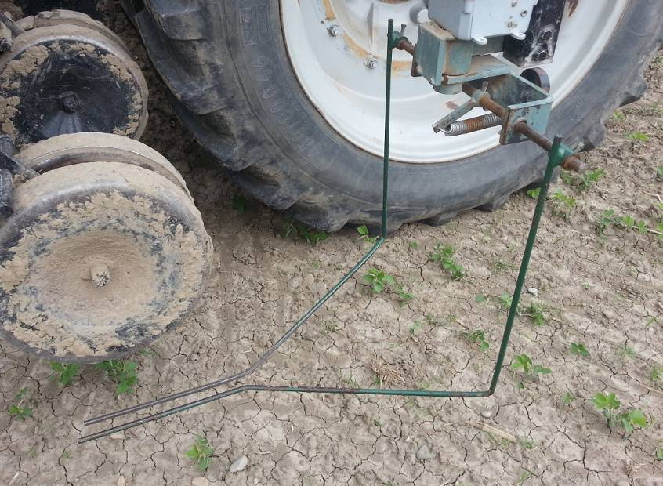
Figure 1. Mechanical guiding rods for crop row detection.

Several non-contact methods have also been developed for row detection, e.g. RTK-GNSS receivers and computer vision. RTK-GNSS offers high accuracy and is commonly available on North American farms. Several hitch manufacturers have adopted RTK-GNSS for implement guidance, e.g. the ProTrakker 500DB (ProTrakker, Odebolt, Iowa, USA) and the Orthman GPS Tracker IV (Orthmann Manufacturing Inc., Lexington, Nebraska, USA). The relative positions of the implement and tractor are dynamic, e.g. for pull-type and articulated-hitch implements, and therefore, a secondary receiver is needed on the implement itself. Although many organic farmers are equipped with RTK-GNSS for tractor auto-steering, equipping each active tractor with an additional receiver, i.e. two per cultivator, is prohibitively expensive for many small-scale producers. As such, the adoption of RTK-GNSS for hitch steering systems has been relatively low as compared to mechanical guiding rods.

As an alternative to guiding rods and RTK-GNSS, computer vision has the potential to be a non-contact, precise, and relatively low-cost method for row detection. Research has explored a variety of imaging methods, such as RGB color cameras and more advanced multispectral imaging systems (Slaughter, 2008). Computer vision techniques have been shown to be capable of detecting the lateral offset of crop rows relative to the implement with a high degree of reliability and accuracy (Tillett, 1991). Similarly, computer vision offset detection has been successfully employed as a component of a high-precision testing system used to verify the performance of tractor auto-steer with a resolution of 2 mm on concrete (Easterly, 2010). By integrating computer vision systems into agricultural platforms, guidance precision can be increased which allows the implement to clean a greater region between crop rows. Applications of computer vision have demonstrated that it can be a reliable method for row detection in various crops, such as sugar beet (Tillett, 2002) and cereals (Hague, 2006), and is effective for feedback and control of agricultural implements (Slaughter, 1999). Several different methodologies have been proposed for identifying the relative position of the crop rows, including stereovision mapping (Kise, 2005), implementation of Hough Line Transform (Rovira-Más, 2005), and band-pass filters (Hague 2001), among others. However, the development of a low-cost system which is capable of analyzing images from basic cameras in diverse ambient lighting conditions and is compatible with a variety of hitch steering systems could further increase adoptability of computer vision row detection.
To address the limitations of guiding rods during early-season inter-row cultivation, a computer vision system was developed to interface with a common hydraulic hitch steering system. The challenges inherent to designing a computer vision cultivation system include: 1) differentiating between the crop row, soil, and weeds, a process known as crop segmentation, 2) estimating lateral error based on the camera perspective, and 3) guidance correction of the cultivator implement via the actuation of a hitch steering system.

Crop Segmentation
With respect to the segmentation of green vegetation (e.g., for crop row tracking or weed detection), a significant amount of research has been focused on developing robust color indices. Using unfiltered RGB images from conventional digital cameras is not employed due to the high inter-correlation between the three color channels (Brivot, 1996). Research has shown that imaging a combination of bands in the visible and infra-red (IR) spectrum produces reliable results due to the high reflectance of green and IR (Slaughter, 2008). However, this approach requires specialized camera systems. Therefore, if using RGB data, images should be transformed to an alternate color index which is more advantageous for plant segmentation. Specialized color indices have been developed for agricultural applications, such as Excess Green (ExG) (Woebbecke, 1995) or the Vegetative Index (VEG) (Hague, 2006). Standard indices such as Hue-Saturation-Value (HSV) and normalized RGB (Figure 2) have also been used successfully for plant segmentation (Moorthy, 2015).
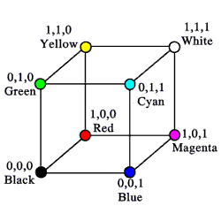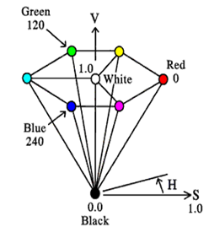
Figure 2. Graphical representation of the RGB (left) and HSV (right) color-spaces. Reprinted with permission by Otto (2000).

During the process of crop detection, varying ambient light is one of the major limiting factors for successfully implementing computer vision plant segmentation. Variations in ambient light occur naturally with changes in weather and time of day, and can dramatically change the appearance of crop foliage in a digital image with respect to texture and color. Additionally, non-uniform lighting intensity, e.g. shadows, are also a major concern. Non-uniform lighting results in irregular variance in the intensity of pixels and increases the complexity of segmenting plants using color indices. This necessitates implementing adaptive procedures for crop segmentation where constant and uniform algorithm parameters do not perform adequately due to varying illumination (McCarthy, 2010). Therefore, any robust segmentation algorithm must have the ability to dynamically change thresholding parameters under different lighting conditions to provide consistent performance.
Thresholding techniques proposed for segmenting images include dynamic thresholding methods
(Rovira, 2005), Otsu-based thresholding methods (Meyer, 2008), and statistical mean-based segmentation (Guijarro, 2011). Thresholding has been shown to be both computationally efficient and functional, but these methods generally assume that the histogram of the image is bimodal, i.e. that the vegetation and the background belong to two different brightness regions (Meyer, 2008). Although thresholding reduces error caused by varying ambient lighting, such methods may exhibit lower performance for non-uniform illumination conditions within the same image (Tian, 1998). To address this concern, research efforts have focused on developing adaptive algorithms for vegetation segmentation, for example, the Environmentally Adaptive Segmentation Algorithm (EASA) (Tian, 1998), or the mean-shift-based learning procedure proposed by Zheng et al. (2009). Although these methods perform well for changing conditions, they add computational complexity. Recent improvements, such as a the Naive Bayes learner proposed by Moorthy et al. (2015), have reached similar levels of accuracy compared to the state-of-the-art EASA, yet are capable of faster processing times and lower memory usage.

Camera Perspective
After successfully segmenting plants within the image, the lateral offset of the crop row must be determined. Methods for estimating the lateral offset can be grouped into two classes based on whether the camera’s angle of inclination is either equal to zero, or greater than zero; these classes are referred to as vertical or oblique, respectfully (Figure 3).
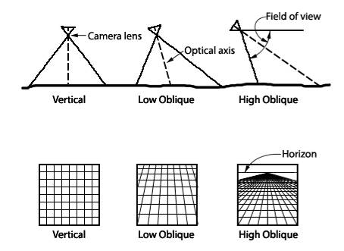
Figure 3. Oblique and vertical viewing angles. Reprinted from Wolf et al. (2000).

Vertical methods, also known as orthogonal perspective, rely on a camera system which faces vertically downward and is directly aligned with a single crop row of the cultivator. An early, yet effective, approach proposed by Olsen et al. (1995) for detecting the lateral offset of the crop relies on taking the sum of the pixel elements gray values in the direction of travel. The resulting curve represents the likelihood of the row’s position for each x-index within the image. To isolate the most probable offset, two separate methods were compared: 1) a least squares regression of a sinusoidal wave, and 2) a Fourier Fast Transform low-pass filter. Both filtration methods achieved an error of 10 mm in cereals, but performed poorly on sugar beets due to their characteristically large leaf volume. In a similar study by Slaughter et al. (1999), an algorithm for detecting the lateral offset of the row using individual segmentation of plants in the image was proposed. For each plant, a histogram of the intensities was calculated which was then used to find the median offset of each plant. If a plant’s median was significantly different than the other plants in the image, it was considered a weed and disregarded. The row offset was then calculated based on the medians of the remaining plants. This method was tested on lettuce and tomatoes for use with a band sprayer operating at 8 km/h, and achieved a standard error of 9 mm and 95th percentile error of 12 mm.
Conversely, oblique perspective methods rely on a camera with a positive angle of inclination and thus multiple rows are present in the field of view. One approach for row estimation with an oblique view utilizes the Hough Line Transform (HLT). In a study by (Pla, 1997), a system using HLT performed with an average error of 18 mm when detecting linear rows in cauliflower and sugar beets. A similar oblique perspective approach using a band-pass filter proposed by Hague et al. (2001) utilized prior knowledge of the spacing of the crop rows of cereals and beets. Supported by the British Beet Research Organization, the system was capable of 3 cm precision at speeds of up to 10 km/h. The project was considered highly successful and was commercialized in 2001 by Garford Farm Machinery (Frognall, Deeping St-James, Peterborough, England, UK) under the name RoboCropTM.
When comparing the vertical and oblique perspective methods, both have advantages and disadvantages. The oblique approach is less sensitive to missing plants and high weed density due to the greater number of visible rows. However, oblique methods rely on prior knowledge of crop spacing and linear rows with low curvature. Additionally, lens distortion is an issue for oblique systems due to the greater subject distance and orientation of the camera. To compensate for increased subject distance, oblique methods require a higher resolution camera, which in turn results in greater computational requirements and costs.
Comparatively, orthogonal systems optimize resolution, in pixels-per-centimeter, and require only basic calibration. However, the reduced field of view for orthogonal systems is a concern when there are significant gaps in the crop rows or heavy weed coverage. To address the issues inherent to the orthogonal approach, a system with two or more cameras may provide sufficient redundancy. Additionally, cameras can be oriented width-wise to the crop row to increase the effective field of view along the direction of travel (Slaughter, 1999).

Hitch Steering Systems
Vehicle steering has received tremendous interest and tractor steering systems in modern tractors have achieved precision of less 2.5 cm. However, due to additional dynamics which act on the implement, such as soil forces and topography, solely relying on tractor steering is not applicable in all environments. Therefore, row sensor feedback is often used in conjunction with a hitch steering system. Several different varieties of hitch steering systems exist, including parallelogram hitches, side-shift (push) hitches, pivoting (articulated) hitches, and rotating stabilizers (Figure 4). Actuated hitch systems which rely on disc-steering, e.g. pivoting hitch or rotating stabilizers, and side-shift systems have both seen commercial success (Thacker, 1995).
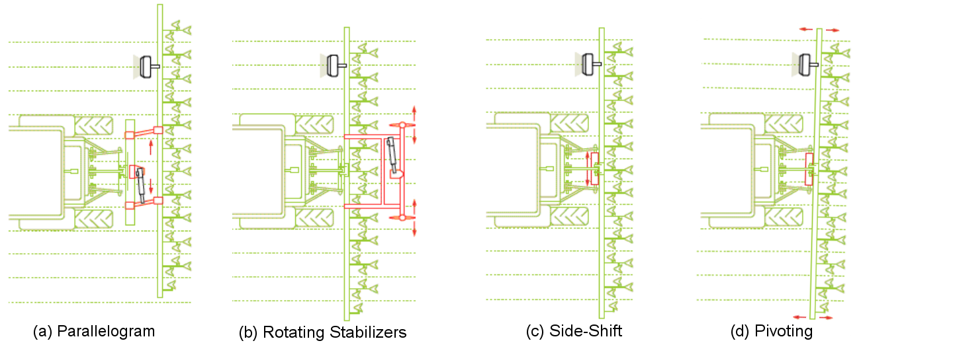
Figure 4. Common styles of hydraulic hitch steering systems. Adapted from Möller (2010).

For light cultivation, disc-steer and side-shift style control have been demonstrated to be effective at speeds under 8 km/h and on flat terrain (Kocher, 2000). However, side-shift and parallelogram systems have been observed to cause problems when the implement is configured for heavier cultivation, e.g. for deep harrows and chisels, due to “jumping”, i.e. the effect of the hitch shifting the tractor. Correcting this problem requires either removing tools or increasing the size of the tractor, both of which may not be practical. Alternatively, disc-steer systems are steered by the lateral force generated by soil resistance on the cultivator discs causing the cultivator to track toward the path of least resistance, e.g. much like that of a rudder on a sailboat. Due to this intuitive mechanism for adjusting the tracking direction of an implement, disc-steer platforms are often preferred by farmers for deeper cultivation practices. However, since disc-steer systems rely on soil resistance, they have been known to exhibit reduced performance in very sandy soils.
The objective of this study was to develop a low-cost and computationally efficient control system to retrofit an electro-hydraulic inter-row cultivator guidance system with computer vision row detection. To be considered effective for commercial use, the lateral error of the guidance system must achieve a 95th percentile lateral error within ±5 cm for travel speeds from 6 to 12 km/h on soy and corn crops from 5 to 20 cm in height.

Materials and Methods
For field evaluation, a twelve row Hiniker heavy cultivator (Hiniker, Co., Mankato, Minnesota, USA) was equipped with a Sukup Auto-Guide hydraulic steering system (Sukup, Sheffield, Iowa, USA) and drawn by a Fendt Vario 850 (AGCO GmbH, Duluth, Georgia, USA). The cultivator tool-bar was configured for a row spacing of 30 inches and equipped with finger weeders, disc-harrows, and wide tine plows. A computer vision guidance system was developed to interface with the hydraulic solenoid controller and serve as an alternate row detection sensor to the mechanical guiding rods (Figure 1). The remaining components of the hydraulic guidance system, including the hitch control module, center-pivot potentiometer (i.e. hitch position sensor), and hydraulic solenoids were left unmodified. This configuration allowed the tractor operator to easily switch between the two modes of row detection between trials during field testing.
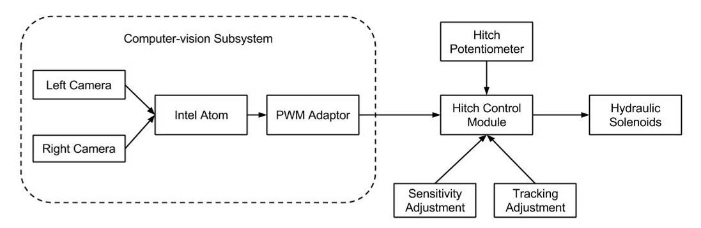
Figure 5. Diagram of the computer vision system integrated with hydraulic controller.

Images of the plants passing beneath the cultivator were acquired with two weather-proof cameras: 1/3" Red-Green-Blue (RGB) complementary metal-oxide semiconductor (CMOS) sensor, and aperture of 2.4 (F), and 6.0 mm focal length (Shenzhen Yufei Technology Co., Shenzhen, China). The cameras were attached to the cultivator tool-bar via specially designed brackets which allowed for both lateral and vertical adjustments. In a compromise between the orthogonal and perspective methods, the cameras were mounted at a low-oblique perspective of 30° inclination from vertical, with the wide image axis aligned with the direction of travel, and at a subject depth of 1.0 m (Figure 6). This approach provided an extended longitudinal field of view, a resolution of approximately 1 mm/px, and relatively low tangential distortion. In order for the system to tolerate regions of high weed density or gaps in the crop rows, the cameras were installed on the 3rd from center rows of the cultivator tool-bar.
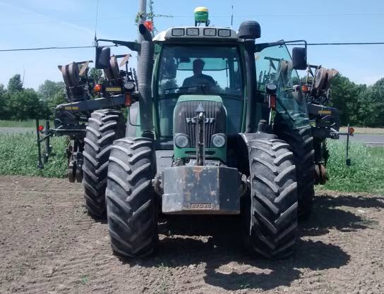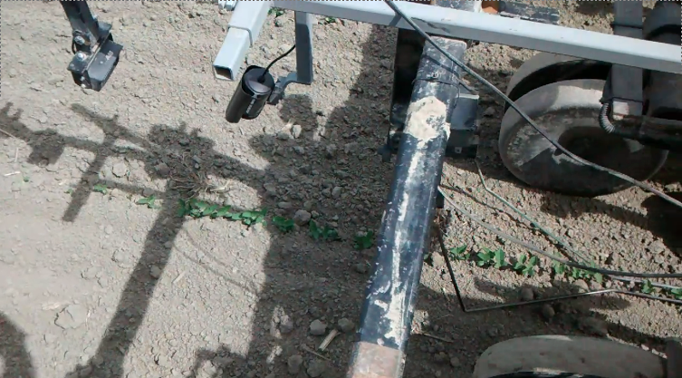
Figure 6. Test tractor and adjustable mounting system for camera and guiding rods.

An embedded Linux controller was developed based on the Debian 7.8 operating system and optimized for the dual-core 1.8 GHz Intel Atom D525 Pineview architecture (Intel Corp., Santa Clara, California, USA). The system's hardware consisted of a NC9MGL-525 Mini-ITX motherboard (Jetway Computer Corp., Newark, California, USA) equipped with an 8 GB solid-state drive (SSD) (Mushkin, Inc., Englewood, California, USA) and 2 GB of rapid-access memory (RAM) (Micron Technology Inc., Boise, Idaho, USA). A run-time application and image processing server was developed predominantly using C++, the Python programming language (v.2.7.6) (Python Software Foundation, Welmington, Delaware, USA), and the OpenCV libraries (v.2.4.5) (Itseez, Inc., San Francisco, California, USA). The application functioned as a local server for performing computer vision analysis, handling peripheral devices, and displaying a graphical interface to the tractor operator (Figure 7).
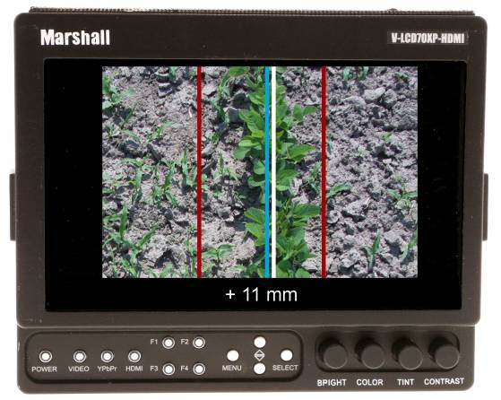
Figure 7. Graphical front-end for tractor operator.

Later versions were configured to host a wireless ad-hoc network which allowed operators to tune system parameters via a mobile application. To generate the output voltage signal to the hydraulic control system, an ATmega328P microcontroller (Atmel Corp., San Jose, California, USA) was implemented as an 8-bit pulse-width modulation (PWM) generator with a 490 Hz switching frequency. The microcontroller was controlled via the Universal Serial Bus (USB) as a serial peripheral device with the microprocessor serving as the USB host. This robust platform proved to be a fault-tolerant, cost-effective system with sufficient computing power for real-time analysis of the images from the two cameras.

Plant Segmentation
In order to detect the crop rows, images were captured from the two CMOS cameras at a frame-rate of 25 frames/s. As a pre-processing step, both cameras were configured to manually downscale to a resolution of 320 × 240 pixels. After capturing each image, the image matrix was transformed from the Red-Green-Blue (RGB) color-space to the Hue-Saturation-Value (HSV) color-space in order to simplify color analysis and reduce the complexity of applying band-pass image filters:
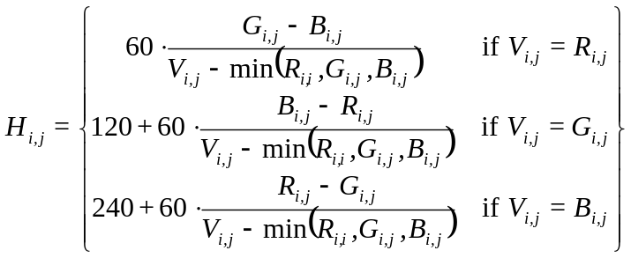 (1)
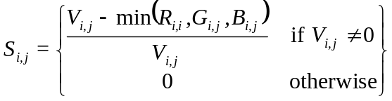 (2)
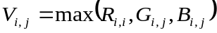 (3)
After transforming the image to the HSV color-space, a band-pass plant detection filter (BPPD) was applied to isolate pixels which could represent plant foliage using a fast percentile filtering method similar to the method discussed by Duin et al. (1986). The BPPD filter selects for pixels with hue from yellow-green to blue-green, saturation within percentile bounds, and values (i.e. brightness) between the extremes of under- and over-exposed. Thresholding values were determined empirically using a training set of sample images in varying light and crop conditions. During this process, it was observed that the cameras experienced significant blue-shifting of crop foliage in very bright or low light, so the upper threshold for hue was set well into the cyan-blue region. This change did not have any noticeable negative impact on performance due to the relative absence of blue-tones in soil.
(4)
where n is the percentile of the sorted array A of length N.
(5)
where H_{min} = 45 (yellow-green), H_{max} = 105 (blue-green), a was the lower saturation percentile (33rd percentile), b was the upper saturation percentile (99th percentile), α was the lower value percentile (15th), and β was the upper value percentile (95th).
The BPPD filter utilized the linear interpolation percentile function (Equation 4) to calculate the upper and lower thresholds of the value and saturation channels. This approach eliminated the need for static limits and reduced false-positive classification of pixels under varying lighting conditions. As a final post-processing step, a morphological opening with a 3 by 3 elliptical Gaussian kernel was applied to the BPPD mask to minimize any remaining noise while preserving the structure of crop foliage (Figure 7). This three step process was found to be computationally non-intensive, yet produced sufficient segmentation in diverse lighting conditions. Notably, the percentile-based band-pass filters of saturation and intensity produced reliable masks for the majority of the worst-case scenarios of poor exposure and shadows (Figure 8).
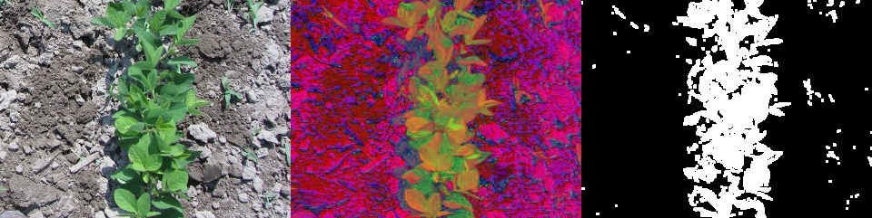
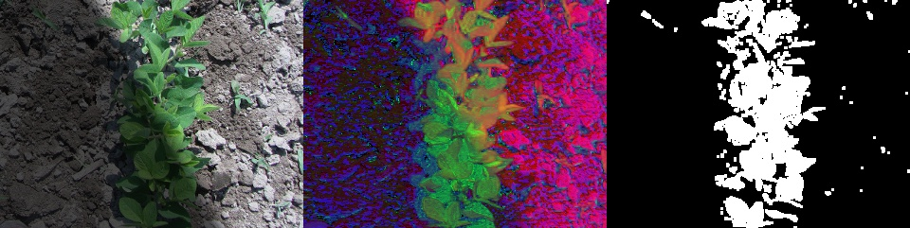
Figure 8. BPPD algorithm applied to image with diffuse lighting (above) and non-uniform lighting (below).

Row Estimation
Due to the non-Gaussian distribution of crop foliage in an image, a two-camera weighted histogram filter (referred to here as 2CWH) was used to estimate the lateral offset of the crop row. First, the column summation of the BPPD mask (M) was calculated in the direction of travel resulting in an array (C) representing the lateral distribution of plant foliage within the image:
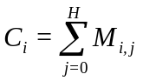 (7)
where H is the height of the image (pixels), and M is the binary matrix produced by the BPPD filter.
Indices of the array with low values suggest bare-soil, moderate values suggest sparsely distributed weeds, and higher values suggest presence of the crop row due to the longitudinal alignment of the plant foliage. Using this distribution, the centroid of the crop row was estimated by applying a high-pass percentile threshold to select for indices which demonstrated significantly greater longitudinal alignment than others. For the camera resolution of 1 mm/px and 480 mm field-of-view, the 95th percentile corresponded to a width of 26 mm, i.e. 1 inch rounded to a resolution of 2 mm:

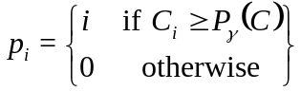 (8)
where P is the percentile function, and γ is the percentile threshold (95th percentile).
The resulting array (p) consists of all indices of the image which are most likely to represent the crop row. The estimated lateral of the crop row for each camera was estimated by taking the weighted centroid of the probable indices, where the weight of each index was the normalized value of its corresponding column summation:
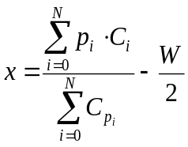 (9)
where N is the number of elements in p, and x is the position of the estimated centroid (in pixels).
To compensate for errors in the detection process inherent to single camera systems, the row centroid estimation process was repeated for each image, producing two column summation arrays (C₁ and C₂) and two estimated centroids of lateral offsets (x₁ and x₂). After calculating the row centroid for each camera, the magnitude of the column summation values for each lateral offset were compared to determine the final estimated offset of the crop row:
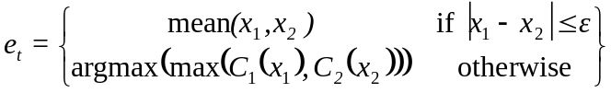 (10)
where ε is the maximum acceptable error tolerance (30 pixels), and e_{t} is the estimated offset error at time t.
This method for row detection prioritized estimations from the two cameras which were in agreement. In the event of a significant difference between the two estimates, the dominant centroid was assumed to be the best estimate of the lateral offset. The 2CHF approach provided an effective means for reducing errors due to weeds and row gaps which was computationally non-expensive (Figure 9).

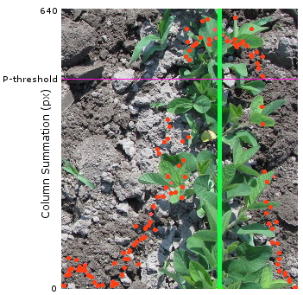
Figure 9. Row estimation by histogram thresholding.

For performance evaluation, the lateral error of the crop row in pixels was converted to centimeters based on the mounting configuration of the camera. For cameras at a subject depth of 1.0 m measured from the lens to the image centroid, the horizontal field-of-view was determined empirically to be approximately 48 cm when measured laterally along the center-line. For an image width of 240 px, this resulted in a resolution of 0.2 cm/px. Due to the semi-orthogonal perspective of the camera and narrow region of interest (±25 px from center), tangential distortion and radial distortion was assumed to be insignificant along the lateral axis.

Electro-Hydraulic Control
Hydraulic steering of the cultivator was achieved by actuating two 0.75 m stabilizers mounted 1.65 m behind the cultivator tool-bar and spaced at a distance of 1.48 m apart (Figure 10). The hydraulic actuation of the stabilizers had a ±75° angular range of motion and a max angular velocity of 22°/s. The two stabilizers were actuated via a hysteresis-style hydraulic-solenoid controller. Actuation of the hydraulic system was determined by the voltage differential between the feedback signal from the row sensor, either the guiding rods or computer vision system, and a rotary potentiometer mounted to the active mechanism of the hitch (Figure 4).

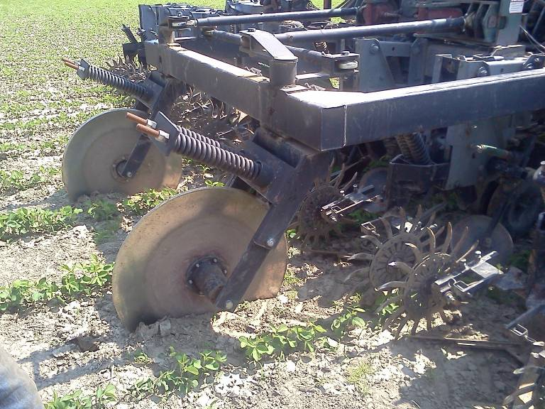
stabilizers
Figure 10. Rotating stabilizers of cultivator steering system.
For the computer vision module, signal conditioning of the output was implemented based on a discrete Proportional-Integral-Derivative (PID) feed-back controller, where the tuning coefficients were initially chosen to provide similar response to that of the guiding rods and were subsequently modified by trial and error:
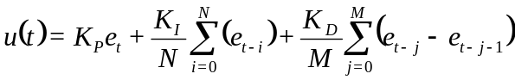 (3.12)
where u is the output value, e is the array of estimated offset values stored in memory, K_{P} = 1.0, K_{I} = 4.0,
K_{D} = 0.5, N = 16 is the number of integral samples, M = 8 is the number of differential samples,
The output value was transmitted as character commands at a polling frequency of 16 Hz to the PWM controller via a weatherproof (IP68) universal serial bus (USB) interface. The microcontroller used in this study operated at a logic-level of 5.0 VDC and therefore was capable of generating a 0.0 - 5.0 VDC PWM output signal. However, the input range of the Sukup Auto-Guide system was observed to be 0.10 V to 8.0 V with a fixed supply of 9.7 Volts. To account for this discrepancy in voltage levels between the systems, a metal-oxide semiconductor field-effect transistor (MOSFET) logic-level converter circuit (Figure 11) was implemented to scale the PWM signal from 5.0 VDC to 9.7 VDC.
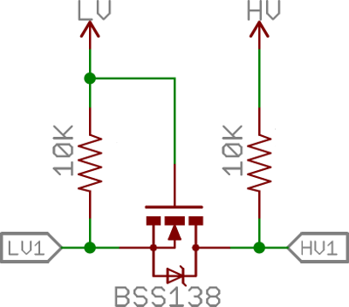
Figure 11. MOSFET logic level converter circuit for adjusting voltage levels.

The output voltage corresponding to a given bit-value can be calculated with the following conversion:
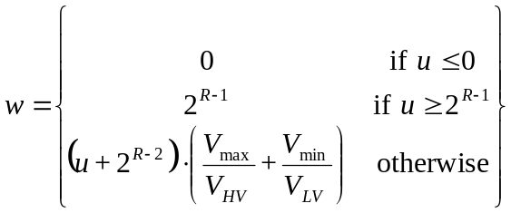 (13)
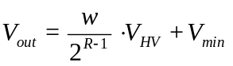 (14)
where V_{min} = 0.10, V_{max} = 8.00, V_{HV} = 9.70, V_{LV} = 5.0
This circuit configuration allowed for a resolution of 200 bits and enabled the computer vision subsystem to interface with hydraulic controllers of differing voltage requirements. Notably, the Sukup Auto-Guide was an analog controller, whereas not all data-acquisition systems (DAQ) are intended for reading PWM signals. In the event of interfacing with a digital hydraulic controller which does not support a PWM input signal, digital-to-analog conversion can be achieved with a low-pass filter (Alter, 2006). Due to the very low impedance requirements of DAQ systems, recommended values for resistance and capacitance are 1.5 Ω and 470 μF, respectively. This configuration results in a first-order system with a time constant of 0.0007 seconds, cutoff frequency of 226 Hz, and a gain of -5.93 dB at 490 Hz, and therefore causes minimal bandwidth-loss for the PWM signal.

Camera Calibration
Before conducting each set of field trials, the following camera calibration procedure was followed to ensure proper alignment of the cameras: 1) the cultivator was aligned with the crop rows which was verified by measurements with a tape measure at the working tools; 2) lateral adjustments were made to the camera bracket to ensure the vertical center-line of each camera was aligned with the crop row; 3) vertical adjustments made to the camera bracket to ensure a subject depth of 1.0 m when measured in a direct line-of-sight from the camera lens to the soil surface. In addition to setup of the camera bracket, all tractor hydraulics were set to their default settings. The hydraulic controller settings were adjusted via the hydraulic control modules user interface which provided both sensitivity and tracking adjustment inputs (Figure 12). The sensitivity adjustment effectively mapped the output range between the sensor voltage and radial resolution of the stabilizers, with a range of 1 to 10 resulting in a linear relationship from 7.7°/V to 18.8°/V, respectively. Similarly, the tracking adjustment offset the zero position of the stabilizers, with a scale of -3 to +3 corresponding to -25° to +25°, respectively. Therefore, at the beginning of each set of trials the following settings were ensured: 1) the sensitivity was set to 10 out of 10, and 2) the tracking adjustment was set to 0.
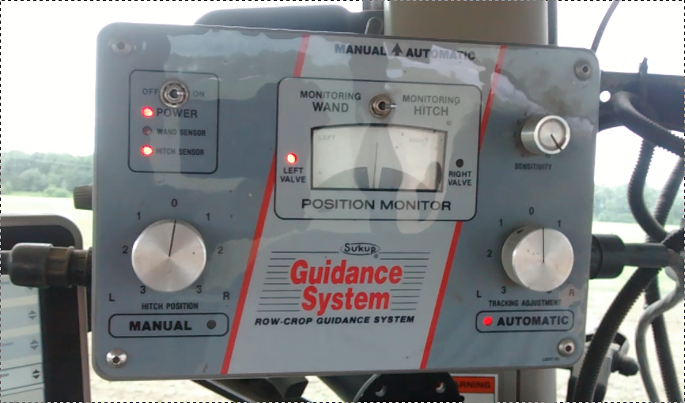
Figure 12. Control module for the Auto-Guide hitch steering system (Sukup, Sheffield, Iowa, USA).

3.2.5 Field Trials
Field tests of the system took place over the summer of 2014 from June to August on straight-drilled corn and soybean crops. Only organic crops were considered in this study. No pesticides were applied to the fields and varying degrees of weed coverage were present during the trials. All fields used for testing were maintained by Agri-Fusion 2000, Inc. (St-Polycarpe, Québec, Canada), a 2500 hectare organic operation. Trials consisted of randomized, single passes across the field from headland to headland. For each pass, five sample points representative of the crop stage were selected and the height of crops at each point was estimated by measuring the distance from the soil surface to the tallest leaflet using a tape measure. The average of the five samples was used to determine the height classification in 5 cm groups, e.g. 0 - 5 cm and 5 - 10 cm, etc. In order to determine the reliability of the two systems at differing speeds of cultivation, trials were conducted at four approximate travel speeds: 6, 8, 10, and 12 km/h. Throughout each trial the following data was logged to file: 1) the lateral error estimated by the computer vision system, 2) RTK-GNSS coordinates,
3) PWM voltage output, and 4) time which the image was captured to within 1 ms. Figure 13 presents the estimated lateral error for two different trials of the same crop, stage and travel speed.
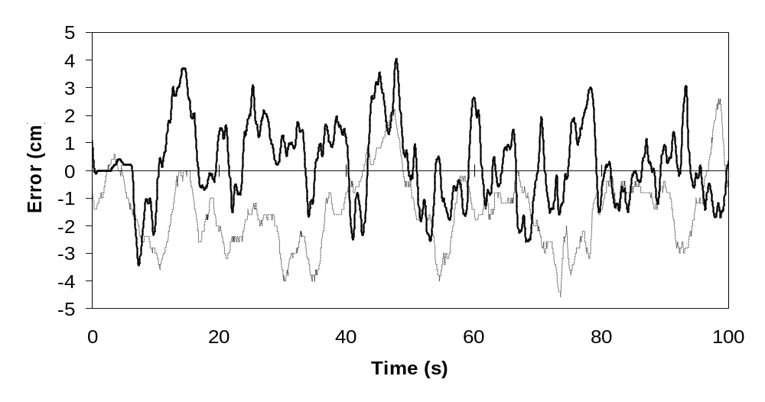
Figure 13. Two computer vision trials (10 - 15 cm soy at 8 km/h) conducted on different fields.

Prior to each trial, both the tractor and cultivator implement were aligned with the crop row to the best of the operator's ability. Once aligned, either the computer vision (CV) or guiding rod (GR) sensor were connected as the control input to the hydraulic module (Figure 3.10). Once ready, the system logger was started, the travel speed was set via the automatic speed controller of the vehicle, and the tractor was engaged into gear. During all trials, the tractor was manually operated by a professional driver without the aid of auto-steering. Due to farm management restrictions with respect to crop health and best management practices for cultivation, some combinations of crop stage and travel speed were not tested extensively, e.g. travel speed of 12 km/h was not tested at the <10 cm height stage due to the high probability of causing excessive damage to seedlings.

Results
Table 1 presents a summary of all trials conducted, including duration of the trial and estimated crop height. As can be seen, there is noticeably lower performance with respect to both RMSE and 95th percentile error for guiding rods when used on crops at the earlier stages of growth.
Table 1. Summary of all trials.
Treatment | Crop Stage | Height (cm) | Speed (km/h) | Duration (s) | RMSE (cm) | 95th Percentile (cm)
Computer Vision (CV) | Corn (>15 cm) | 20 | 6 | 55 | 1.7 | 3.0
 |  | 15 | 8 | 81 | 4.3 | 5.2
 |  | 15 | 8 | 112 | 1.5 | 3.0
 |  | 25 | 8 | 140 | 1.9 | 3.6
 |  | 20 | 10 | 189 | 1.7 | 3.4
 |  | 20 | 10 | 225 | 1.7 | 3.0
 |  | 20 | 12 | 193 | 2.2 | 4.0
 | Soy (<10 cm) | 5 | 6 | 334 | 0.5 | 0.6
 |  | 5 | 6 | 149 | 0.9 | 1.2
 |  | 5 | 6 | 431 | 0.6 | 1.0
 |  | 10 | 6 | 476 | 1.5 | 2.6
 |  | 10 | 6 | 375 | 1.3 | 2.5
 |  | 10 | 6 | 71 | 1.7 | 3.8
 |  | 10 | 8 | 80 | 2.1 | 4.0
 |  | 10 | 10 | 61 | 2.1 | 3.8
 |  | 10 | 10 | 50 | 1.4 | 2.4
 | Soy (10 - 15 cm) | 15 | 6 | 313 | 1.0 | 1.8
 |  | 15 | 8 | 360 | 1.8 | 2.8
 |  | 15 | 8 | 313 | 1.6 | 2.8
 |  | 15 | 8 | 139 | 3.6 | 7.0
 |  | 15 | 10 | 380 | 1.5 | 3.0
 |  | 15 | 12 | 418 | 1.7 | 2.8
 | Soy (>15 cm) | 25 | 8 | 437 | 2.5 | 3.4
 |  | 20 | 10 | 360 | 2.1 | 3.0
 |  | 20 | 12 | 353 | 1.7 | 3.0
 |  | 25 | 12 | 98 | 2.5 | 3.6
 |  | 25 | 12 | 298 | 2.8 | 5.4
 |  | 20 | 12 | 205 | 1.9 | 3.4
Guiding Rods (GR) | Corn (>15 cm) | 20 | 6 | 167 | 1.6 | 3.0
 |  | 20 | 6 | 338 | 3.7 | 6.8
 |  | 15 | 8 | 195 | 2.0 | 3.8
 |  | 15 | 8 | 211 | 1.7 | 3.0
 |  | 25 | 10 | 274 | 2.0 | 3.8
 |  | 20 | 12 | 128 | 2.3 | 4.4
 | Soy (<10 cm) | 10 | 8 | 84 | 3.4 | 7.0
 |  | 10 | 6 | 58 | 2.6 | 4.6
 |  | 10 | 8 | 84 | 3.5 | 5.6
 |  | 10 | 6 | 76 | 3.5 | 6.6
 |  | 10 | 10 | 101 | 5.0 | 10.2
 | Soy (10 - 15 cm) | 15 | 8 | 140 | 3.2 | 5.8
 |  | 15 | 8 | 100 | 4.2 | 7.0
 |  | 15 | 10 | 145 | 2.9 | 6.0
 |  | 15 | 10 | 138 | 4.6 | 8.4
 |  | 15 | 12 | 96 | 5.0 | 9.8
 | Soy (>15 cm) | 20 | 6 | 556 | 2.0 | 4.0
 |  | 20 | 6 | 625 | 1.0 | 2.4
 |  | 20 | 10 | 344 | 1.5 | 2.4
 |  | 25 | 10 | 156 | 1.3 | 2.8
 |  | 25 | 12 | 107 | 1.7 | 3.0
 |  | 25 | 12 | 146 | 2.8 | 6.2
 |  | 25 | 12 | 104 | 1.4 | 2.6
 |  | 25 | 12 | 153 | 1.9 | 3.0

Table 2 presents 95th percentile and RMSE values for trials grouped into four crop-stages: Soy <10 cm, Soy 10-15 cm, Soy >15 cm, and Corn >15 cm. With respect to RMSE, both methods for row detection performed sufficiently for field use, with an average RMSE of 2.88 cm and 1.90 cm for all trials using computer vision and guiding rod systems, respectively. However, since the guidance error within a given trial can be said to be non-parametric, the 95th percentile should be considered as a more reliable metric of the system performance with respect to agricultural guidance system standards (ISO, 2012).
Table 2. RMSE and 95th Percentile with respect to crop species and height.
 | RMSE (cm) |  |  |  | 95th Percentile (cm)
Treatment | Soy  (<10 cm) | Soy  (10 - 15 cm) | Soy  (>15 cm) | Corn  (>15 cm) | Soy  (<10 cm) | Soy  (10 - 15 cm) | Soy  (>15 cm) | Corn  (>15 cm)
CV | 1.36 | 1.87 | 2.22 | 2.15 | 2.43 | 3.37 | 3.63 | 3.60
GR | 3.61 | 3.98 | 1.70 | 2.22 | 6.80† | 7.40† | 3.30 | 4.13
† exceeds the acceptable lateral error for cultivation (±5.0 cm), indicating possible damage to crops

Table 3 presents the pair-wise t-test of 95th percentile errors grouped by crop-stage with respect to the row sensor used. As can be seen, there was a significant decrease in error when using the guiding rods for crops greater than 15 cm in height.
Table 3. Pair-wise t-test of 95th percentile errors for computer vision (CV) compared to guiding rods (GR).
 |  | CV |  |  | GR
Crop | Stage (cm) | Mean (cm) | Std error (cm) | Trials | Mean (cm) | Std error (cm) | Trials | Mean diff. (cm) | p-value
Soy | < 10 | 2.87 | 1.08 | 7 | 6.8 | 2.12 | 5 | -3.93 | 0.009*
Soy | 10 - 15 | 3.37 | 1.83 | 6 | 7.4 | 1.69 | 5 | -4.03 | 0.010*
Soy | > 15 | 3.63 | 0.90 | 6 | 3.3 | 1.28 | 8 | 0.33 | 0.297
Corn | > 15 | 3.60 | 0.80 | 7 | 4.1 | 1.41 | 6 | -0.53 | 0.225
* significant at a confidence of α = 0.05

Table 4 presents the results of multiple-comparison analysis by Tukey's Honest Significant Difference (HSD) test with respect to the row sensor used. When disregarding crop type and grouping trials by height alone, the two row detection methods showed no significant difference at the 10 - 15 cm crop height.

Table 4. Tukey HSD multiple comparison of 95th percentiles (irrespective of crop species).
 | Group 1 |  | Group 2
 | Treatment | Stage (cm) | Treatment | Stage (cm) | Mean diff. (cm) | Std error (cm) | p-value
CV vs. CV | CV | < 10 | CV | 10 - 15 | 0.78 | 0.30 | 0.454
CV vs. CV | CV | < 10 | CV | > 15 | 0.72 | 0.28 | 0.459
CV vs. CV | CV | 10 - 15 | CV | > 15 | -0.06 | 0.29 | 0.900
CV vs. GR | CV | < 10 | GR | < 10 | 2.26 | 0.34 | 0.001*
CV vs. GR | CV | < 10 | GR | 10 - 15 | 1.81 | 0.30 | 0.001*
CV vs. GR | CV | < 10 | GR | > 15 | 0.62 | 0.28 | 0.603
CV vs. GR | CV | 10 - 15 | GR | < 10 | 1.48 | 0.35 | 0.052
CV vs. GR | CV | 10 - 15 | GR | 10 - 15 | 1.03 | 0.31 | 0.197**
CV vs. GR | CV | 10 - 15 | GR | > 15 | -0.16 | 0.29 | 0.900
CV vs. GR | CV | > 15 | GR | < 10 | 1.54 | 0.33 | 0.024*
CV vs. GR | CV | > 15 | GR | 10 - 15 | 1.09 | 0.29 | 0.100
CV vs. GR | CV | > 15 | GR | > 15 | -0.10 | 0.26 | 0.900
GR vs. GR | GR | < 10 | GR | 10 - 15 | -0.45 | 0.35 | 0.900
GR vs. GR | GR | < 10 | GR | > 15 | -1.64 | 0.33 | 0.014*
GR vs. GR | GR | 10 - 15 | GR | > 15 | -1.19 | 0.29 | 0.057
* significant at a confidence of α = 0.05
** not significant when classified by crop height alone (see Table 3.3)

Discussion
Overall, the guiding rods exhibited significantly greater 95th percentile error relative to the computer vision system for the <10 cm and 10 - 15 cm crop stages of soy (Table 1). However, the accuracy of the guiding rods increased dramatically as the plants matured, resulting in a significant decline in both 95th percentile and RMSE (Table 2). Conversely, the computer vision system demonstrated a slight increase in 95th percentile error as crop height increased. This effect is possibly attributable to the greater crop foliage area of mature plants reducing the precision of row centroid estimation. However, the correlation between crop height and 95th percentile of the computer vision system was determined to not be statistically significant (Table 4).
Linear regression of 95th percentile values revealed that the performance of the guiding rod system decreased as a function of travel speed for the <10 cm and 10 - 15 cm stages (Figure 14). Conversely, the computer vision system did not exhibit the same effect for the tested range of 6 km/h to 12 km/h. These results suggest that in order to achieve a 95th percentile error of less than 5.0 cm when using guiding rods with underdeveloped crops it is necessary to reduce the speed of cultivation. This conclusion corresponds to the reported experiences of tractor operators when using the guiding rod systems with smaller plants. The positive correlation between 95th percentile error and travel speed is attributable to the increased probability of the guiding rods losing the crop row when traveling at speeds in excess of 8 km/h. Due to the mechanical action of row estimation via guiding rods, higher speed cultivation causes the rods to exert greater stress on underdeveloped plants, thus resulting in poor tracking and damage to the seedlings. Therefore, it can be asserted that the computer vision method for row detection is a more robust solution than mechanical guiding rods with respect to early season cultivation.
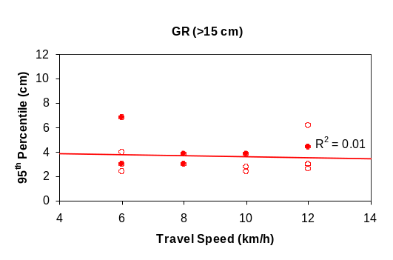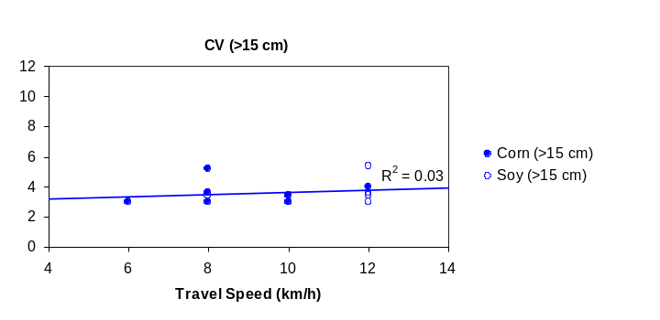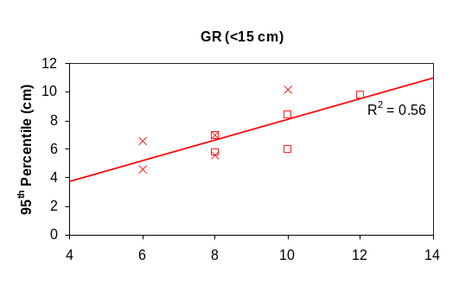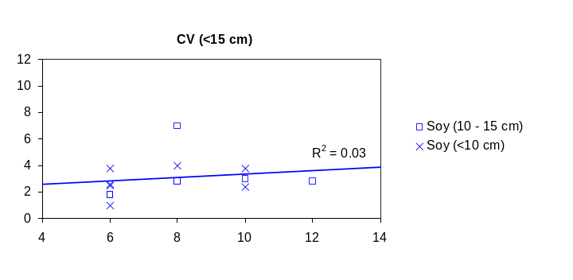
Figure 14. Guiding rod (GR) and computer vision (CV) 95th percentile errors with respect to travel speed and grouped by crop height.

Future Improvements
For this study, row offsets were determined by analyzing the plant foliage mask in the direction of travel with a relatively small subject distance and cameras mounted at a low-oblique perspective (Figure 3). Due to the low angle of inclination, close subject depth, small region of interest, and orthogonal method for row estimation it was not necessary to incorporate tangential or radial distortion correction. However, for alternate usage cases, e.g. cameras aligned at the mid-point between rows or at subject depths greater than 1.0 m, it would be necessary for tangential and radial distortion correction to be implemented (Figure 15).
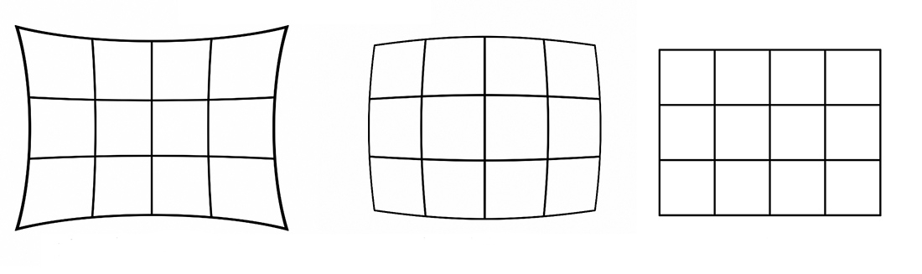
Figure 15. Illustration of radial lens distortion.
Due to the variable nature of how computer vision row detection systems are installed, a versatile method for in-field camera calibration, such as that demonstrated by Lee et al. (2009), may be well suited to address distortion correction. The method utilizes a checkerboard pattern which is placed in the camera’s field of view. An image is captured and the positions of the corners are identified. Using the known size of the squares, the tangential and radial distortion coefficients (P_{n} and K_{n}, respectively) can be determined empirically. Once the distortion coefficients are known, each newly captured image can be rectilinearized using the Brown-Conrady model of distortion correction (Brown, 1966):
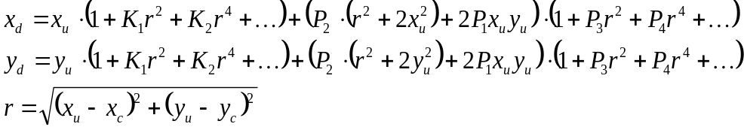 (15)
where (x_{d}, y_{d}) is the distorted image point as project on image plane using lens, (x_{u}, y_{u}) undistorted image point project by ideal pin-hole camera, (x_{c}, y_{c}) is the distortion center, K_{n} is n^{th} radial distortion coefficient, P_{n} is the n^{th} tangential distortion coefficient.
With respect to the style of hydraulic hitch, this study was restricted to a rotating-stabilizer guidance system where the cultivator tool-bar was parallel to the tractor axle at all times. When cultivating straight-drilled rows, the cameras were effectively aligned with the direction of travel. As such, the proposed method for row detection discussed in this paper is only appropriate for both rotating stabilizer and center-shift steering systems where the camera's field of view is in-line with the crop row under most conditions. However, several commercially available cultivator guidance systems are based on pivoting hitch and parallelogram style systems (Figure 3.3). Preliminary testing of the row detection method proposed in this work has been undertaken for the AcuraTrak 3G pivoting hitch (Sunco Manufacturing, Inc., North Platte, Nebraska, USA) with generally positive results.
In pivoting hitch systems, the cultivator tool-bar is rotated about a central pivot-point to guide the implement in the desired direction by generating lateral adjustment forces on cultivator discs. This design can eliminate the “tail-out” effect which is caused when the tractor is following a curved path (Thacker, 1996). However, pivoting hitch steering systems may rotate the cultivator tool-bar as much as ±10°. For cameras mounted to the tool-bar, this pivoting action effectively changes the apparent orientation and lateral error of the crop row. To compensate for this effect, knowledge of the camera's position relative to the pivot point is required as well as the camera's instantaneous orientation relative to the direction of travel. Although the cultivator orientation may be determined via sensor feedback from the hitch itself (e.g. via a rotary encoder), an approach which utilizes the information already provided by a camera is an attractive option. Methods such the Hough Line Transform or feature-based visual tracking of the images (i.e. keypoint tracking) may prove to be robust solutions which do not require additional sensors and would therefore be system-agnostic. For example, by tracking the motion of the ground moving beneath the cultivator, the orientation of the camera relative to the crop rows can be estimated and subsequently compensated for (Appendix C).
Due to the inherent nature of agriculture control systems, numerous uncontrollable variables exist which can have a detrimental effect on system performance, e.g. soil conditions, terrain slope, hydraulic pressure, and travel speed. These dynamic external factors can ultimately impact the performance of the system. As seen previously in Figure 3.11, two computer vision trials which were conducted on the same crop-stage and travel speed but on different fields demonstrated noticeably different behaviors, specifically with respect to bias and response time.
To account for non-linearity and variability inherent to implement guidance, an adaptive control system would be a viable solution to reduce the need for regular re-calibration (e.g., when switching between a
disc-steer and side-shift hitch system), human intervention, or additional feedback sensors on implements,
e.g. fifth wheels or tilt-sensors. Reinforcement learning techniques, such as Q-learning (Watkins, 1992), are well suited to this style of control system and have produced successful results for robotics and automotive applications with variable load requirements, such as DC motor control (Aziz, 2015) and active suspension systems (Chiou, 2012). The Q-learning algorithm is primarily intended for applications which require uncalibrated control of non-linear, multiple-input, multiple-output systems. Q-learning is based on the principal of a reward mechanism, i.e. for a given action the resulting behavior of a system can be automatically classified by the system and subsequently rewarded or penalized. Actions which result in positive behavior for a given state of the system (e.g., adjusting gain offsets due to bias) are incentivized and those which resulted in negative behavior (e.g., high gains resulting in overshooting) are penalized. Ultimately, the learning process produces a non-linear response matrix which adapts to the current working environment of the system.
A particularly interesting subset of modern control systems, known as fuzzy logic controllers (FLCs), have been investigated for facilitating PID tuning (Visioli, 1999) and for systems which adaptively self-tune their parameters (Güzelkaya, 2003). Unlike classical PID controllers, FLC systems incorporate fuzzy logic either to classify the behavior of a system or to adjust gain coefficients in order to optimize performance (Boubertakh, 2010). Q-learning has been demonstrated to be a viable complement to FLCs in non-linear, complex systems, such as active automotive suspension systems (Chiou, 2012) and variable-load DC motor control (Aziz, 2015). Applications of adaptive controllers in agriculture have the potential to improve performance and reduce calibration when working with varying implement configurations and field conditions.
The dual-camera BPPD row estimation method proved to be an effective method for plant segmentation in various lighting and crop conditions, including in the presence of weed coverage. Using computer vision as sensor input for a rotating-stabilizer hydraulic steering system significantly improved the precision of inter-row cultivation at the early stages of crop growth. The computer vision system outperformed the guiding rods at the <10 cm stages of soy and corn, with a mean improvement of 2.26 cm. When controlling for different crop species, the computer vision system outperformed the guiding rods at the <10 cm and 10 - 15 cm stages of soy, with a mean differential of 3.93 and 4.03 cm, respectively. However, at the later stages of growth, i.e. soy and corn >15 cm, there was no significant difference in performance between the two guidance systems. Thus, we conclude that computer vision row sensors can be incorporated as low-cost embedded systems to improve the precision of critical early-season cultivation operations, but that mechanical guiding rods continue to be a robust and sufficient method for detection in the later stages of cultivation.

Conclusion
The dual-camera BPPD row estimation method proved to be an effective method for plant segmentation in various lighting and crop conditions, including in the presence of weed coverage. Using computer vision as sensor input for a rotating-stabilizer hydraulic steering system significantly improved the precision of inter-row cultivation at the early stages of crop growth. The computer vision system outperformed the guiding rods at the <10 cm stages of soy and corn, with a mean improvement of 2.26 cm. When controlling for different crop species, the computer vision system outperformed the guiding rods at the <10 cm and 10 - 15 cm stages of soy, with a mean differential of 3.93 and 4.03 cm, respectively. However, at the later stages of growth, i.e. soy and corn >15 cm, there was no significant difference in performance between the two guidance systems. Thus, we conclude that computer vision row sensors can be incorporated as low-cost embedded systems to improve the precision of critical early-season cultivation operations, but that mechanical guiding rods continue to be a robust and sufficient method for detection in the later stages of cultivation.

Acknowledgements
This study was supported in part by funding provided through the National Science and Engineering Research of Canada (NSERC) Engage program with assistance from Jean Cantin of the Quebec Ministry of Agriculture, Fisheries and Food (MAPAQ).
References
Aziz, K. A., El-Bardini, M., & El-Rabaie, N. M. (2015). Embedded Adaptive Fuzzy Controller Based on Reinforcement Learning for DC Motor with Flexible Shaft. Arabian Journal for Science and Engineering, 40(8), 2389-2406.
Bàrberi, P. (2002). Weed management in organic agriculture: are we addressing the right issues?. Weed Research, 42(3), 177-193.
Boubertakh, H., Tadjine, M. Glorennec, P.Y., & Labiod, S. (2010). Tuning fuzzy PD and PI controllers using reinforcement learning. ISA Transactions, 49(4), 543-551.
Brivot, R., & Marchant, J. A. (1996). Segmentation of plants and weeds for a precision crop protection robot using infrared images. IEE Proceedings-Vision, Image and Signal Processing, 143(2), 118-124.
Brown, Duane C. (1966). Decentering distortion of lenses. Photogrammetric Engineering, 32 (3), 444–462.
Chiou, J.S., Tsai, S.H. & Lui, M.T. (2012). A PSO-based adaptive fuzzy PID-controller. Simulation Modeling Practice and Theory, 26, 49-59.
Damian, A. (2011). Weed control in maize crop by mechanical and manual management practices. Scientific papers USAMV Bucuresti, Series A: Agronomy, 262-268.
Dong, F., Mitchell, P. D., Hurley, T. M., & Frisvold, G. B. (2016). Quantifying Adoption Intensity for Weed-Resistance Management Practices and Its Determinants among US Soybean, Corn, and Cotton Farmers. Journal of Agricultural and Resource Economics, 41(1), 42-61.
Guijarro, M., Pajares, G., Riomoros, I., Herrera, P. J., Burgos-Artizzu, X. P., & Ribeiro, A. (2011). Automatic segmentation of relevant textures in agricultural images. Computers and Electronics in Agriculture, 75(1), 75-83.
Hague, T., & Tillett, N. D. (2001). A bandpass filter-based approach to crop row location and tracking. Mechatronics, 11(1), 1-12.
Hague, T., Tillett, N. D., & Wheeler, H. (2006). Automated crop and weed monitoring in widely spaced cereals. Precision Agriculture, 7(1), 21-32.
ISO. (2012). ISO 12188-2: Tractors and machinery for agriculture and forestry -- Test procedures for positioning and guidance systems in agriculture -- Part 2: Testing of satellite-based auto-guidance systems during straight and level travel. Geneva, Switzerland: ISO.
Jones, P.A., Blair, A.M., & Orson, J.H. (1996). Mechanical damage to kill weeds. International Weed Control Congress, Copenhagen.
Kise, M., Zhang, Q., & Más, F. R. (2005). A stereovision-based crop row detection method for tractor-automated guidance. Biosystems Engineering, 90(4), 357-367.
Kocher, M.F., M.B. Smith, R.D. Grisso and L.J. Young. (1994). Performance Comparison for Two Types of Implement Guidance Systems. Paper No.94-3574, ASAE International Winter Meeting, 13-16 DEC 1994, Atlanta, GA. 21p.
Kocher, M. F., Smith, M. B., Grisso, R. D., & Bashford, L. L. (2000). Performance tests of three-point mounted implement guidance systems: I. Procedure. Biological Systems Engineering: Papers and Publications, 169.
Lee, S. H., Lee, S. K., & Choi, J. S. (2009). Correction of radial distortion using a planar checkerboard pattern and its image. Consumer Electronics, IEEE Transactions on, 55(1), 27-33.
Livingston, M., Fernandez-Cornejo, J., Unger, J., Osteen, C., Schimmelpfennig, D., Park, T., & Lambert, D. M. (2015). The economics of glyphosate resistance management in corn and soybean production. Economic Research Report No. ERR-184, US Department of Agriculture.
Meyer, G. E., Mehta, T., Kocher, M. F., Mortensen, D. A., & Samal, A. (1998). Textural imaging and discriminant analysis for distinguishing weeds for spot spraying. Transactions of the ASAE, 41(4), 1189-1197.
Meyer, G. E., & Neto, J. C. (2008). Verification of color vegetation indices for automated crop imaging applications. Computers and Electronics in Agriculture, 63(2), 282-293.
Moorthy, S., Parvathi, K. M., Boigelot, B., & Mercatoris, B. (2015, July). Effective segmentation of green vegetation for resource-constrained real-time applications. In 10th European Conference on Precision Agriculture.
Norsworthy, J. K., Ward, S. M., Shaw, D. R., Llewellyn, R. S., Nichols, R. L., Webster, T. M., & Witt, W. W. (2012). Reducing the risks of herbicide resistance: best management practices and recommendations. Weed Science, 60(1), 31-62.
Olsen, H. J. (1995). Determination of row position in small-grain crops by analysis of video images. Computers and electronics in agriculture, 12(2), 147-162.
Pla, F., Sanchiz, J. M., Marchant, J. A., & Brivot, R. (1997). Building perspective models to guide a row crop navigation vehicle. Image and vision computing, 15(6), 465-473.
Robati, J., Navid, H., Rezaei, M., & Ghiasi, A. R. (2012). Automatic Guidance of an Agricultural Tractor along with the Side Shift Control of the Attached Row Crop Cultivator. Journal of Agricultural Science and Technology B, 2(1), 151-158.
Rovira-Más, F., Zhang, Q., Reid, J. F., & Will, J. D. (2005). Hough-transform-based vision algorithm for crop row detection of an automated agricultural vehicle. Proceedings of the Institution of Mechanical Engineers, Part D: Journal of Automobile Engineering, 219(8), 999-1010.
Slaughter, D. C., Chen, P., & Curley, R. G. (1999). Vision guided precision cultivation. Precision Agriculture, 1(2), 199-217.
Slaughter, D. C., Giles, D. K., Fennimore, S. A., & Smith, R. F. (2008). Multispectral machine vision identification of lettuce and weed seedlings for automated weed control. Weed Technology, 22(2), 378-384.
Thacker, G. W., & Coates, W. E. (1995). Precision Guidance Techniques to Reduce Weed Competition and Production Costs in Cotton. Cotton: A College of Agriculture Report.
Thacker, G. W. and W.E. Coates. (1995b). Practical Considerations of Precision Guidance and Weed Control in Cotton. Cotton, A College Thacker, G. W., & Coates, W. E. (1995). Practical Considerations of Precision Guidance and Weed Control in Cotton. Cotton: A College of Agriculture Report.
Thacker, G. W., & Coates, W. E. (1996). How the quick hitch guidance systems work and their practical applications. Cotton: A College of Agriculture Report.
Tian, L. F., & Slaughter, D. C. (1998). Environmentally adaptive segmentation algorithm for outdoor image segmentation. Computers and Electronics in Agriculture, 21(3), 153-168.
Tillett, N. D. (1991). Automatic guidance sensors for agricultural field machines: a review. Journal of agricultural engineering research, 50, 167-187.
Tillett, N. D., Hague, T., & Miles, S. J. (2002). Inter-row vision guidance for mechanical weed control in sugar beet. Computers and Electronics in Agriculture, 33(3), 163-177.
Woebbecke, D. M., Meyer, G. E., Von Bargen, K., & Mortensen, D. A. (1995). Color indices for weed identification under various soil, residue, and lighting conditions. Transactions of the ASAE, 38(1), 259-269.
Wolf, P. R. & Dewitt, B. A. (2000). Elements of Photogrammetry: with applications in GIS (Vol. 3). New York: McGraw-Hill.
Zheng, L., Zhang, J., & Wang, Q. (2009). Mean-shift-based color segmentation of images containing green vegetation. Computers and Electronics in Agriculture, 65(1), 93-98.

